**STORM WATER POLLUTION PREVENTION PLAN NARRATIVE**

**(Addresses TPDES TXR150000 General Permit; Effective Date 03-05-2023)**

FOR

|  |
| --- |
| **PROJECT NAME** |
| **Wildflower Northeast Phase** |
| **LOCATION** |
| NW of Sam Reynolds Rd. & Cindy’s Ln. Fort Worth, TX 76247 |

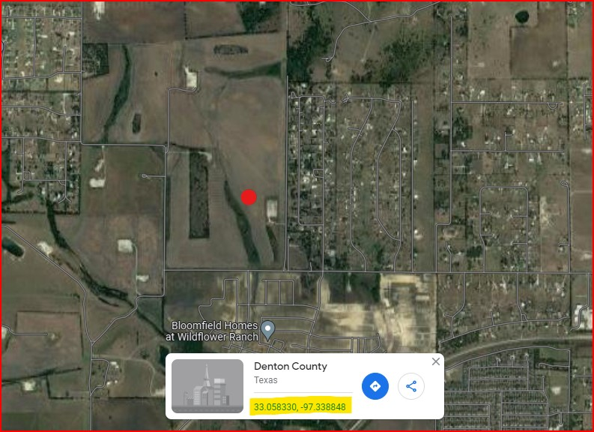

|  |  |
| --- | --- |
| **Operator (Primary)** | **HT HWY 114 development, LP** |
| **Project Description** | Site development to support construction of a Single-family Home Lot Sub-Division with phasing to include excavation, utilities, paving, and landscaping. |
| **Disturbed Area(s)** | 121.11 acres |
| **Type of Construction Activity** | Large Construction Activity >5acre |
| **TCEQ Permit Documents** | Construction Site Notice (CSN)  Notice of Intent Application (NOI) |

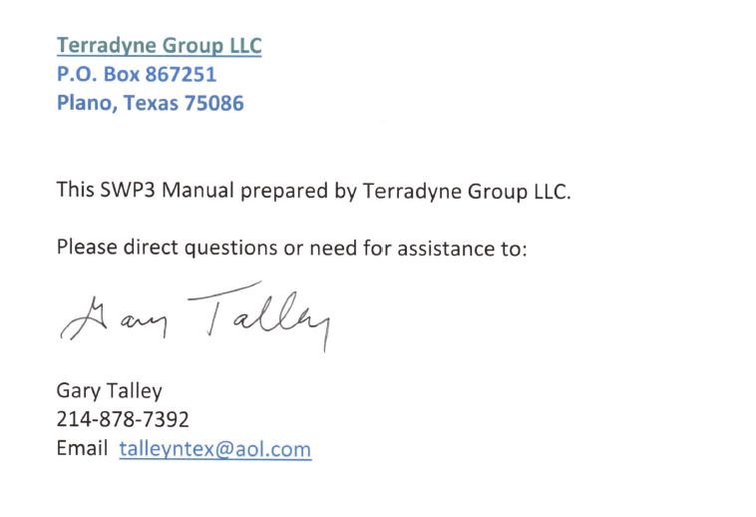

**This SWP3 Narrative is written for the following project:**

**Wildflower Northeast Phase**

Located @ NW of Sam Reynolds Rd. & Cindy’s Ln. Fort Worth, TX 76247

SWPPP Preparation Date: 06/02/2023

**Operator:**

|  |  |
| --- | --- |
| **HT HWY 114 development, LP** | Operator in control of daily operations |
| **HT HWY 114 development, LP** | Operator in control of plans and specs |

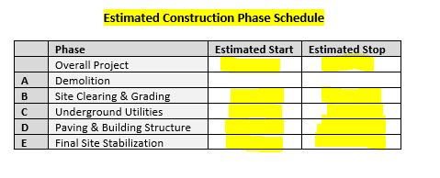

**Table of Content**

* **Introduction**
* **Instructions / Procedural Requirements**
* **Section 1: SWP3 Signature Documents**
  + 1. Operator Certification Statement
    2. TCEQ Construction Site Notice (CSN)
    3. TCEQ Delegation Letter
    4. Endangered Species and Historic Places Acknowledgement
    5. Operator Responsibilities
    6. TCEQ Notice of Intent (NOI) Application
    7. TCEQ NOI Payment
    8. TCEQ Notice of Change (NOC)
    9. TCEQ Notice of Termination (NOT)
* **Section 2: Project Site Information**

A. Site Description and Construction Activity Description

B. List of Allowable Non-Storm Water Discharges

C. List of Potential Pollutants and Pollutant Sources

D. SWP3 Site Maps

* **Section 3: Construction Phases and BMP Sequence & Controls**

A. Construction Phases and Sequence of BMP Controls

B. Temporary and Permanent Stabilization Practices

* **Section 4: BMP Description and Structural Controls**
* **Section 5: Copy of TXR150000 Regulations**
* **Section 6: SWP3 Site Inspection and Maintenance**
* **Section 7: SWP3 Record Keeping Logs**
* **Section 8: Appendix**

Appendix 1 - Historic Places

Appendix 2 - Endangered Species Information

Appendix 3 - NCTCOG BMP specs

Appendix 4 - Erosion Control Plan

**INTRODUCTION**

This SWP3 document outlines procedures that address the current March 5, 2023 requirements of the TPDES General Permit Number TXR150000 Relating to Storm Water Discharges Associated with Construction Activities. The current regulations expire at midnight on March 5, 2023. During construction, all operators and their contractors and subcontractors must comply with the General Permit requirements; a copy of which is included in this manual.

This document is intended to be the narrative which when combined with the erosion and sediment control drawing for this project forms the basis of the SWP3.

The SWP3 should be revised as needed to accommodate additional regulations or ordinances that local municipalities, the State if Texas or the Federal government may require.

The TXR150000 General Permit authorizes defined Operator’s to discharge the following from the construction site and from offsite support areas:

* Storm Water Runoff
* Discharges of Storm Water associated with Construction Support Activities

As defined in TXR150000 Part II.A.2

* Non-Storm Water Discharges

As defined in TXR150000 Part II.A.3

The following acronyms are used throughout this manual:

* BMP- Best Management Practices
* CSN- Construction Site Notice
* MS4- Municipal Separate Storm Sewer System
* NOC- Notice of Change
* NOI- Notice of Intent
* NOT- Notice of Termination
* SWP3- Storm Water Pollution Prevention Plan
* TCEQ- Texas Commission on Environmental Quality

**INSTRUCTIONS / PROCEDURAL REQUIREMENTS**

**A. Prior to initial earth disturbing activity, complete all of the following:**

|  |  |
| --- | --- |
| **1** | Review manual and complete **Section 1**: **SWP3 Signature Documents**  Note: Follow instructions for distribution of SWP3 documents. |
| **2** | Review **Section 3** for selection of appropriate BMPs and erosion/sediment  controls for this site. Implement practices and install controls in accordance  with the schedule for the various phases of earth disturbing activities. |
| **3** | Post a **SWP3 Sign** displaying the signed CSNs (Construction Site Notice) at the  project entrance for public viewing (Owner’s and Contractor’s) |
| **4** | Provide **Section 6**: **SWP3 Site Inspection Reports** and corrective actions. |
| **5** | Provide record keeping information in **Section 7: SWP3 Logs** |
| **6** | Review the following Introduction-**Section B: On-Going Requirements** |
| **7** | Review the following:  **Introduction**-**Section C: End of Project-Terminating the Permit** |
|  | **Important Note: Provisional Authorization Period**   * Small Construction Activities requiring a signed CSN are provisionally   authorized immediately. |
|  | **Important Note:**   * Retain proof of all mailings and postmark dates. |

**B. On-Going Requirements**

|  |  |
| --- | --- |
| **1** | **SWPPP Site Inspections, Corrective Action and Record Keeping**  The Operator must conduct scheduled inspections to assure compliance with this SWPPP. Based on inspection results, the SWPPP may require modification to assure the quality of storm water or non-storm water discharge is leaving the site in compliance with the Storm Water Regulations. Written inspections by the Operator designee or its 3rd party designee are intended to verify site compliance or identify non-compliance issues needing correction.  Responsibilities of the Operator’s site manager or supervisor include:   * Inspection reports should be read immediately * Initiate Corrective Actions in a timely manner to maintain effective controls. * Perform record keeping in the SWP3 (See Section 7: SWP3 Logs). |
| **2** | **SWPPP Revisions and NOC (Notice of Change) Form**  Revise the SWPPP as follows:   * To reflect new Operators on-site or new areas of responsibility that may be added. * Update in writing each time there are significant modifications to construction design activities requiring additional or modified BMP controls & practices. * Amend the SWPPP at any time if it is found to be inadequate in addressing conditions of the TPDES General Permit or any amendments to the permit. * Submit changes of significant information to TCEQ via the NOC (Notice of Change) Form as defined in TXR150000 General Permit Part II.Section E.6. * **A copy of the NOC Form is located in Section 1 of this SWP3 Manual.** |
| **3** | **SWPPP Plan Review**  The SWPPP and supporting documents should be available for review by keeping on-site if possible or post the location and contact information if kept off-site.   * State regulations require the SWPPP and supporting documents be available for at least 3 years after termination of permit. This provision ensures that all records are available in the event the documents need to be reviewed. * All records and supporting documents should be compiled in an orderly fashion. * The SWP3 is not submitted to TCEQ unless the Executive Director specifically requests a review copy which if requested should be submitted in a timely manner. * Review can be requested by state or local municipal operator with a storm water permitted municipal separate storm sewer system (MS4). |
| **4** | **SWPPP Record Keeping**  Record keeping by the Operator’s project supervisor is very important as the Operator can be audited by various agencies such as the local municipality, TCEQ and EPA. Potential of fines exist for lack of documentation and failure to implement an effective SWPPP. The SWPPP Manual can be audited for accuracy at any time.  Operator’s project supervisor is required to provide the following record keeping (See Section 7: SWP3 Logs):   * Written inspection reports dated entries in the SWP3 Logs and SWP3 Site Map Drawing (accurate depiction of controls and location of sources of pollution). * Record all revisions to the SWPPP as may be necessary. |

|  |  |
| --- | --- |
| **5** | **Hazardous Substance Discharge/Spills**  In the event of a spill of a hazardous substance, the operator is required to notify the National Response Center (1-800-424-8802) to report the spill and the Department of Public Safety Station No. 4 at (972) 574-7725 for assistance in cleanup of the spill. In addition, the operator shall submit a written description of the release (including the type and amount of material released, the date of the release, the circumstances of the release, and the steps to be taken to prevent future spills) to the EPA regional office in Dallas. The SWPPP must be revised within 14 calendar days after the release to reflect the release, stating the information above along with modifications to minimize the possibility of future occurrences. Each contractor and subcontractor is responsible for complying with these reporting requirements. |
| **6** | **Phased BMP and Structural Controls**  Provide BMP and erosion/sediment controls as needed for each phase of construction. Refer to SWP3 Manual for phasing of controls. |
| **7** | **Site Supervisor’s Checklist**  Site manager should provide the following:   * Practice ‘Good House Keeping’ on a daily basis: Pick-up trash and floatable debris on and off the construction site, clean offsite streets, clean and repair storm drain inlet protectors, provide dust control, repair damaged controls prior to next rain event. * Add improved controls as needed when existing controls are not adequate. * Review all SWP3 logs and record necessary information. * Initiate temporary stabilization of disturbed areas within 14 days where construction activity will cease for more than 21 days. (ie. vegetation, perimeter controls or other measures such as erosion mat or rock). |
| **8** | **Disclaimer: Important information**    This book is a guide and workbook for the permitted Operator to choose BMPs to keep the site in compliance to the TXR150000 Storm Water Discharge Regulations for General Construction Activity  This Narrative does not attempt to provide for the design of the site's erosion & sediment control. Design for erosion & sediment control should be sourced from a qualified Civil Engineer. However, sites are considered dynamic when it comes to storm water runoff design so changes to BMP controls are often necessary as compared to the original civil design.    Changes and deviations to the original Civil Design are captured with notations on required 'SWPPP site maps' and with SWPPP Log information. The SWPPP operator through their representative or their 'SWPPP designee' (ie. Site Superintendent) should become totally familiar with the contents of this manual.  Some primary duties are to create written inspection reports reports for identifying non-compliance issues, to capture data in the SWPP Logs that are provided in the SWPPP Narrative and create updates to the SWPPP Site Map.    The civil engineer's 'Erosion & Sediment Control' drawing, if available for this project, is normally used as the basis for the SWPPP Site Map and for adding future hand notations regarding changes and revisions to the BMP controls. If a civil drawing is not available, a schematic should be provided indicating location of BMP controls and other items defined in the regulations such as dirt stock piles portable toilets, concrete washouts, storm water outfalls, drainage arrows etc.    Updates and entries to the SWPPP Logs and SWPPP Site Map is the responsibility of the SWPPP site designee (ie. site superintendent) and possibly in conjunction with a 3rd party SWPPP Inspector, if a 3rd party inspector has been hired for this site. Log entries should include capturing accurate BMP locations, removal of controls, location of site stabilization, etc. The 3rd Party SWPPP Inspector has a basic duty of providing a written report of 'observations of noncompliance items'. The 3rd Part Inspector can often assist the site SWPPP Designee, ie. site superintendent, in entering data into the SWPPP record such as SWPPP Logs and SWPPP site map. Failure to include this data may result in violations & fines by city, state or federal environmental officers, if an audit is performed, so choosing not to perform these task represent risk to your project operations.  Failure to respond to noncompliance items such as needs for repairs, cleaning of BMP controls or needs for additional controls is not acceptable and can result in violations with possible fines. |

**C. End of Project: Terminating the Permit**

|  |
| --- |
| **Conditions of Termination**  Operator’s permit must be terminated within 30 days after any of the following conditions occur:   1. Final stabilization achieved on all portions of the site where permittee is responsible. 2. A transfer of operational control has occurred (Review TXR150000 Section II.F.4.). 3. Operator obtained alternative authorization under an individual or general TPDES permit. |
| **Small Construction Activities**  Each operator that has obtained automatic authorization and has **not** been required to submit an NOI must remove the site notice, complete the applicable portion of the site notice related to removal of the site notice, and submit a copy of the completed site notice to all other Operators, including new Operators, and to the operator of any MS4 receiving the discharge (or provide alternative notification as allowed by the MS4 operator, with documentation of such notification included in the SWP3).  Authorization to discharge under this general permit terminates immediately upon removal of the applicable site notice. Compliance with the conditions and requirements of this permit is required until the site notice is removed. |
| **Large Construction Activities**  Each operator that has submitted an NOI for authorization under this general permit must apply to terminate that authorization by submitting a Notice of Termination (NOT) on a form supplied by the executive director.  **A copy of form located in Section 1 of this SWP3 Manual**).  Authorization to discharge under this general permit terminates at midnight on the day the NOT is postmarked for delivery to the TCEQ. If electronic submission of the NOT is provided, authorization to discharge under this permit terminates immediately following confirmation of receipt of the NOT by the TCEQ. Compliance with the conditions and requirements of this permit is required until an NOT is submitted.  The NOT must be submitted to TCEQ, and a copy of the NOT provided to all other Operators, including new Operators, and to the operator of any MS4 receiving the discharge the operator of any MS4 receiving the discharge (with a list in the SWP3 of the names and addresses of all MS4 operators receiving a copy). |

**D.** **Documentation of Compliance with Approved State and Local Plans**

|  |  |
| --- | --- |
| **1** | The SWP3 must be revised to be consistent with requirements specified in applicable sediment and erosion control site plans or site permits or storm water management site plans or site permits approved by federal, state or local officials. (Include local storm water pollution ordinances).  Permittee will revise this SWP3 as needed to allow compliance with all current local, state and federal regulations regarding procedural requirements and controls required for storm water pollution prevention. |
| **2** | The SWP3 must be updated as necessary to remain consistent with any changes applicable to protecting surface water resources in sediment erosion site plans or site permits, or storm water management site plans or site permits approved by state or local official for which the permittee receives written notice. |
| **3** | If the permittee is required to prepare a separate management plan, including but not limited to a Water Pollution Abatement Plan or Contributing Zone Plan in accordance with 30 TAC Chapter 213 (related to the Edwards Aquifer), then a copy of that plan must be either included in the SWP3 or made readily available upon request to authorized personnel of the TCEQ. The permittee shall maintain a copy of the approval letter for the plan in its SWP3. |
| **4** | **City of Fort Worth, Texas** erosion control ordinance (s). |



**03.05.23 ADDENDUM 1**

**REVISIONS TO TXR150000 STORMWATER DISCHARGE REGULATIONS**

**03.05.23 ADDENDUM 1**

**New Regulations:**

This addendum 1 references the new TXR150000 regulations issued March 5, 2023 listing ‘revisions and new requirements’ to the TXR150000 Construction General Permit. The permitted Operator’s SWP3 representative(s) (SWP Designee, Project Manager, Site Superintendent, Safety & Swp3 Manager) is advised to ‘read the following and immediately implement all requirements listed’. Some of the requirements are a) procedural and some are b) SWP3 BMP implementation.

Note: Those items noted with an asterisk * are considered changes to the previous TXR150000 regulation and full adherence is required by the Operator(s) to stay in compliance with their stormwater discharge permit.

**PROCEDURAL INFORMATION regarding the TXR150000 Construction General Permit (CGP)**

**READ** the following information regarding your permit and compliance procedures and requirements.

Note: The general permit and your authorized permit will automatically terminate at midnight on March 5, 2028.

**\*revision to prior CGP**

**Acronym(s)**

1. Acronym CGP (Construction General Permit).
2. Acronym CSN (Construction Site Notice).
3. Acronym NOI (Notice of Intent). See CGP page 9.
4. Acronym NOC (Notice of Change). See CGP page 9.
5. Acronym NOT (Notice of Termination). See CGP page 9.
6. Acronym MS4 (Municipal Separate Storm Sewer System). See CGP page 9.

**PART I (TXR150000 pages 5-12): Flow Chart and Definitions**

|  |  |  |
| --- | --- | --- |
| 1 | Read the definition of Commencement of Construction, Construction Activity and Construction Support Activities  CGP Part I.B. Definitions (pg 6). | * |
| 2 | Read the modified the definition of Dewatering  CGP Part I.B. Definitions (pg 6) | * |
| 3 | Updated hyperlink to Edward Aquifer Map Viewer under definition for Edwards Aquifer  CGP I.B. Definitions (pg 7) | * |
| 4 | Read the modified language to the Waters of the United States  CGP I.B. Definitions (pg 12). | * |
| 5 | Added definition of High-Level Radioactive Waste  CGP I.B. Definitions (pg 8). | * |

**PART II (Txr150000 pages 13-27): Permit Applicability and Coverage**

**Section A: Discharges Eligible for Authorization:**

|  |  |  |
| --- | --- | --- |
| 6 | The CGP authorizes discharges from ‘emergency fire-fighting activities’.  Note: Does not include washing of trucks, run-off water from training activities, test water from fire suppression systems or similar activities).  CGP Part II.A.3.a. (pg 13) | * |

**Section C: Limitations on Permit Coverage**

|  |  |  |
| --- | --- | --- |
| 7 | The CGP does not limit the ability of additional or more stringent requirements by federal, state or local government entities. CGP Part II.C.7. removes an out of date reference to local government code. | * |
| 8 | The CGP cannot authorize discharges from the construction of a new facility that is licensed for the storage of High-Level Radioactive Waste.  CGP Part II.C.12 (pg16) | * |

**Section E: Obtaining Authorization to Discharge**

|  |  |  |
| --- | --- | --- |
| 9 | Low Potential for Erosion: Small construction site operators must meet conditions (a)-(h) prior to commencing construction activities.  CGP Part II.E.1 (pg 17) | * |
| 10 | If signatory authority is delegated by an authorized representative, then Operators of Small Construction Activities are to submit via mail the Delegation of Signatories Form on the approved TCEQ paper form. New form submittal is required if the delegation changes to another individual or position.  CGP Part II.E.2.(e) (pg 19) | * |
| 11 | Operators of Large Construction Activities must submit an NOI electronically using the online e-Permits system on TCEQ’s website prior to commencing construction activities. Upon confirmation of the receipt of the electronic form by TCEQ, authorization is immediate.  CGP Part II.E.3.b (pg19) | * |
| 12 | If signatory authority is delegated by an authorized representative, then Primary Operators of Large Construction Activities are to submit via electronically through TCEQ STEERS system the Delegation of Signatories Form. New form submittal required if delegation changes to another individual or position.  CGP Part II.E.3.(e) (pg 20) | * |
| 13 | Large CSN’s must be maintained until final stabilization has been achieved.  CGP Part II.E.3.(c) (pg 20) | * |
| 14 | Operators with an electronic reporting waiver: must submit a completed paper NOI to TCEQ within 7 days prior to commencing construction activity to obtain provisional coverage 48 hours from the postmark date for delivery to the TCEQ.  CGP Part II.E.3.b (pg20); Part II.E.5.b (pg21) | * |
| 15 | A NOI must contain at a minimum the information listed in CGP II.E.8. page 22. |  |
| 16 | The NOI must include an estimate for the start and end date of construction activity.  CGP Part II.E.8.e (pg23) | * |
| 17 | The NOI must include confirmation that the construction activities are not associated with a facility licensed to store high-level radioactive waste by the USNRC.  CGP Part II.E.8.h (pg 23) | * |

**Section F: Terminating Coverage**

|  |  |  |
| --- | --- | --- |
| 18 | Compliance with the conditions and requirements of the CGP is required until a NOT is submitted and approved by the TCEQ.  CGP Part II.F.1 (pg24) | * |
| 19 | For Small Construction Sites and for Secondary Operators, the CSN must be maintained until final stabilization has been achieved.  CGP Part II.F.3 (pg 25) | * |

**Section G: Waivers from Coverage**

|  |  |  |
| --- | --- | --- |
| 20 | Submit waiver applications electronically unless applicants obtain electronic reporting waiver.  CGP Part II.G.1 (pg 25) | * |

**SWP3 CONTENT INFORMATION regarding the SWP3**

**READ** the following information regarding your SWP3 requirements.

**\*Revision to prior CGP**

**PART III: Storm Water Pollution Prevention Plan**

|  |  |  |
| --- | --- | --- |
| 21 | The SWP3 is used to comply with effluent limits and other permit conditions and that Part IV of the permit establishes additional effluent limits.  CGP Part III (pg 29) | * |

**SECTION B: Responsibilities of Operators**

|  |  |  |
| --- | --- | --- |
| 22 | The SWP3 must identify portions of the project where each operator has control.  CGP Part III.B.1 (pg30) | * |

**SECTION E: Revisions and Updates to SWP3**

|  |  |  |
| --- | --- | --- |
| 23 | Revisions and updates to the SWP3 include Site Map changes.  CGP Part III.E. (pg 32) | * |

**SECTION F: Contents of SWP3**

|  |  |  |
| --- | --- | --- |
| 24 | Detailed site map to include: property boundaries, drain patterns, approximate before and after graded slopes, demolition activity, soil disturbance areas.  CGP III.F.1.g (pg 33) | * |
| 25 | Maintain a copy of the Delegation of Signatories form submitted to TCEQ in the SWP3 record. Make it available for review upon request by TCEQ or the local MS4 Operator.  CGP III.F.1.l. (pg 33) | * |
| 26 | Language added to Part III.F.2.a and Part III.F.2.c. for consistency with federal effluent limitations for BMPs used to minimize pollution in runoff.  CGP III.F.2.a and III.F.2.c (pg 34,35,36) | * |
| 27 | Sedimentation basins must be designed for and appropriate for controlling runoff at the site and existing detention or retention ponds at the site may not be appropriate.  CGP III.F.2.c.i.a.1 (pg 36) | * |
| 28 | Permittees shall minimize, to the extent practicable, the off-site vehicle tracking of sediments and dust. The SWP3 shall include a description of controls utilized to control the generation of pollutants that could be discharged in stormwater from the site.  CGP III.F.4.a (pg 37) | * |
| 29 | Permittees shall design and utilize appropriate controls in accordance with Part IV. of this permit to minimize the offsite transport of suspended sediments and other pollutants if it is necessary to pump or channel standing water from the site.  CGP III.F.4.e (pg 37) | * |
| 30 | Observation and Evaluation of Dewatering Controls Pursuant to Part IV.C. of this General Permit:  Personnel provided by the permittee must observe and evaluate dewatering controls at a minimum of once per day on the days where dewatering discharges from the construction site occur. Personnel conducting these evaluations must be knowledgeable of this general permit, the construction activities at the site, and the SWP3 for the site. Personnel conducting these evaluations are not required to have signatory authority for reports under 30 TAC § 305.128 (Signatories to Reports).  Requirements for Observations and Evaluations i. A report summarizing the scope of any observation and evaluation must be completed within 24-hours following the evaluation. The report must also include, at a minimum, the following:  (A) date of the observations and evaluation;  (B) name(s) and title(s) of personnel making the observations and evaluation;  (C) approximate times that the dewatering discharge began and ended on the day of evaluation, or if the dewatering discharge is a continuous discharge that continues after normal business hours, indicate that the discharge is continuous (this information can be reported by personnel initiating the dewatering discharge);  (D) estimates of the rate (in gallons per day) of discharge on the day of evaluation;  (E) whether or not any indications of pollutant discharge were observed at the point of discharge (e.g., foam, oil sheen, noticeable odor, floating solids, suspended sediments, or other obvious indicators of stormwater pollution); and  (F) major observations, including: the locations of where erosion and discharges of sediment or other pollutants from the site have occurred; locations of BMPs that need to be maintained; locations of BMPs that failed to operate as designed or proved inadequate for a particular location; and locations where additional BMPs are needed.  ---  Actions taken as a result of evaluations, including the date(s) of actions taken, must be described within, and retained as a part of, the SWP3. Reports must identify any incidents of non-compliance. Where a report does not identify any incidents of non-compliance, the report must contain a certification that the facility or site is in compliance with the SWP3 and this permit. The report must be retained as part of the SWP3 and signed by the person and in the manner required by 30 TAC § 305.128 (relating to Signatories to Reports).  The names and qualifications of personnel making the evaluations for the permittee may be documented once in the SWP3 rather than being included in each report.  CGP III.F.7 (pg 38,39)  ---  See attached suggested Observation Evaluation Form.  Note: The Operator will need to implement the reporting requirement thru onsite personnel such as the Project Manager or Site Supervisor. Suggest they communicate with all onsite sub-contractors this compliance requirement especially after rain events. This applies to De-watering activities that discharge past the project limits. | * |
| 31 | Reflect the current inspection schedule in the SWP3 record. Inspection frequency can be changed within the first 5 days of a calendar month and the reason for the schedule change.  CGP III.F.8.c.vi. (pg40) | * |
| 32 | Adverse Conditions:  Requirements for inspections may be temporarily suspended for adverse conditions. Adverse conditions are conditions that are either dangerous to personnel (e.g., high wind, excessive lightning) or conditions that prohibit access to the site (e.g., flooding, freezing conditions). Adverse conditions that result in the temporary suspension of a permit requirement to inspect must be documented and included as part of the SWP3. Documentation must include: the date and time of the adverse condition, names of personnel that witnessed the adverse condition, and a narrative for the nature of the adverse condition.  CGP III.F.8.e. (pg 41) | * |
| 33 | Actions taken as a result of inspections, including the date(s) of actions taken, must be described within, and retained as a part of, the SWP3.  CGP III.F.8.g (pg42) | * |
| 34 | The SWP3 must be modified based on the results of inspections, as necessary, to better control pollutants in runoff. Revisions to the SWP3 must be completed within seven (7) calendar days following the inspection. If existing BMPs are modified or if additional BMPs are necessary, an implementation schedule must be described in the SWP3 and wherever possible those changes implemented before the next storm event. If implementation before the next anticipated storm event is impracticable, these changes must be implemented as soon as practicable.  If necessary, modify your site map to reflect changes to your stormwater controls that are no longer accurately reflected on the current site map.  CGP III.F.8.h (pg 42) | * |

**PART IV: Erosion and Sediment Control Requirements Applicable To All Sites**

|  |  |  |
| --- | --- | --- |
| 35 | Review CGP Part IV page 42 for discharge to achieve at a minimum the effluent limitations representing the degree of effluent reduction attainable by application of the best practicable control technology (BPT) currently available to satisfy the Effluent Limitation Guideline (ELG) permitting requirements for application of the additional standards listed in this Part IV section.  CGP IV (pg 42) | * |
| 36 | Except as provided in 40 CFR §§ 125.30-125.32, any discharge regulated under this general permit, with the exception of sites that obtained waivers based on low rainfall erosivity, must achieve, at a minimum, the following effluent limitations representing the degree of effluent reduction attainable by application of the best practicable control technology currently available (BPT). The BPT are also required by and must satisfy the Effluent Limitations Guideline (ELG) permitting requirement for application of 40 CFR § 450.24 New Source Performance Standards (NSPS), 40 CFR § 450.22 Best Available Technology Economically Achievable (BAT), and 40 CFR § 450.23 Best Conventional Pollutant Control Technology (BCT).  CGP IV (pg 42) | * |

**SECTION C: Dewatering**

|  |  |  |
| --- | --- | --- |
| 37 | **Dewatering:** Discharges from dewatering activities, including discharges from dewatering of trenches and excavations, are prohibited, unless managed by appropriate controls to address sediment and prevent erosion. Operators must observe and evaluate the dewatering controls once per day while the dewatering discharge occurs as described in Part III.F.7. of this general permit.  CGP IV.C. (pg44)  See attached suggested Observation Evaluation Form.  Note: The Operator will need to implement the reporting requirement thru onsite personnel such as the Project Manager or Site Supervisor. Suggest they communicate with all onsite sub-contractors this compliance requirement especially after rain events. This applies to De-watering activities that discharge past the project limits. | * |

**SECTION D: Pollution Prevention Measures**

Design, install, implement, and maintain effective pollution prevention measures to minimize the discharge of pollutants. At a minimum, such measures must be designed, installed, implemented, and maintained to:

|  |  |  |
| --- | --- | --- |
| 38 | Minimize exposure of wastes to precipitation, stormwater, and wind  CGP IV.D.3 (pg 44) | * |
| 39 | Minimize exposure of wastes by implementing good housekeeping measures. Wastes must be cleaned up and disposed of in designated waste containers on days of operation at the site. Wastes must be cleaned up immediately if containers overflow.  CGP IV.D.4 (pg 44) | * |
| 40 | Minimize the discharge of pollutants from spills and leaks and implement chemical spill and leak prevention and response procedures. Where a leak, spill, or other release containing a hazardous substance or oil in an amount equal to or in excess of a reportable quantity established under either 40 CFR Part 110, 40 CFR Part 117, or 40 CFR Part 302 occurs during a 24-hour period, you must notify the National Response Center (NRC) at (800) 424-8802 in accordance with the requirements of 40 CFR Part 110, 40 CFR Part 117, and 40 CFR Part 302 as soon as you have knowledge of the release. You must also, within seven (7) calendar days of knowledge of the release, provide a description of the release, the circumstances leading to the release, and the date of the release.  CGP IV.D.5 (pg 44) | * |
| 41 | Minimize exposure of sanitary waste by positioning portable toilets so that they are secure and will not be tipped or knocked over, and so that they are located away from surface water in the state and stormwater inlets or conveyances.  CGP IV.D.6 (pg 44) | * |

**Section F. Surface Outlets**

|  |  |  |
| --- | --- | --- |
| 42 | When discharging from basins and impoundments, utilize outlet structures that withdraw water from the surface, unless infeasible. If infeasible, the permittee must provide documentation in the SWP3 to support the determination, including the specific conditions or time periods when this exception will apply.  CGP IV.F (pg 45) | * |

**SECTION 1: SWP3 Signature Documents**

1. Operator Certification Statement
2. TCEQ Construction Site Notice (CSN)
3. TCEQ Delegation Letter
4. Endangered Species and Historic Places Acknowledgement
5. Operator Responsibilities
6. TCEQ Notice of Intent (NOI) Application
7. TCEQ NOI Payment
8. TCEQ Notice of Change (NOC)
9. TCEQ Notice of Termination (NOT)

**INSTRUCTIONS**

|  |  |
| --- | --- |
|  | **Note:** Read the next page titled “Signature Requirement defined by 30 TAC §305.44” to determine who can provide an authorized signature. |
| **A** | Sign Operator(s) Certification Statement for the Owner and the Contractor(s) Operator. |
| **B** | Operator(s) TCEQ Construction Site Notice (CSN).  Follow instructions for distribution. |
| **C** | Sign the TCEQ Delegation of Authorized Signature letter and mail to the TCEQ address shown. |
| **D** | Read and sign the Endangered Species and Historic Places Acknowledgement |
| **E** | Review the list of Operator Responsibilities and make necessary revisions if needed. |
|  | **Additional requirements: For Large Construction Activities only ( >5 acres)** |
| **F** | Review, complete and sign the TCEQ NOI Application(s) for Operators.  Follow instructions for distribution. |
| **G** | Complete and mail the NOI Payment Submittal Fee Form with attached check of $325 payable to TCEQ. (Note: NOI submittal via TCEQ website is $225.) |
|  | **Important Note:**  Copy all mailed documents and proof of postmark to the SWP3 Record Book. |

|  |  |
| --- | --- |
|  | **Additional requirements: For Large Construction Activities only ( >5 acres)** |
| **H** | Submit a NOC (Notice of Change) Form when significant information changes on the NOI Application. |
| **I** | Submit a NOT (Notice of Termination) Form when permit termination conditions are satisfied. |

**SECTION 1A: SWP3 Signature Documents for:**

**HT HWY 114 development, LP**

A. Operator Certification Statement

B. TCEQ Construction Site Notice (CSN)

C. TCEQ Delegation Letter

D. Endangered Species and Historic Places Acknowledgement

**INSTRUCTIONS**

|  |  |
| --- | --- |
|  | **Note:** Read the next page titled “Signature Requirement defined by 30 TAC §305.44” to determine who can provide an authorized signature. |
| **A** | Sign Operator(s) Certification Statement and file in the SWP3 Record |
| **B** | Operator(s) TCEQ Construction Site Notice (CSN).  1. Review for accuracy  2. Follow instructions for distribution. |
| **C** | Sign the TCEQ Delegation of Authorized Signature letter and send by certify mail to the TCEQ address shown. |
| **D** | Read and sign the Endangered Species and Historic Places Acknowledgement  File in SWP3 Record |

**Signature Requirement defined by 30 TAC §305.44**

The purpose of this document is to clarify the signature requirements for SWPPP Certification Statements, Notice of Intent application, TCEQ Construction Site Notice , Notice of Termination and TCEQ Signature Delegation Letter subject to 30 Texas Administrative Code (TAC) section (§)305.44. Signature on these documents must meet the requirements as defined below:

**For Corporations:**

The regulation governing who may sign an application form is 30 TAC §305.44(a)(1). According to this provision, any corporate representative may sign an application form so long as the authority to sign such a document has been delegated to that person in accordance with corporate procedures. By signing the application form, you are certifying that such authority has been delegated to you. The TCEQ may request documentation evidencing such authority.

**For Municipality or other Government Entity:**

The regulation governing who may sign an application form is 30 Texas Administrative Code

§305.44(a)(3). According to this provision, only a ranking elected official or principal executive officer may sign an application form. Persons such as the City Mayor or County Commissioner are ranking elected officials. The principal executive officer may be identified in your city charter, county or city ordinances, or the Texas statute(s) under which your governmental entity was formed. An application form that is signed by a governmental official who is not a ranking elected official or principal executive officer does not conform to §305.44(a)(3). The signatory requirement may not be delegated to a government representative other than those identified in the regulation. By signing the application , you are certifying that you are either a ranking elected official or principal executive officer. Documentation demonstrating your position as a ranking elected official or principal executive officer may be requested by the TCEQ.

**30 Texas Administrative Code §305.44. Signatories to Applications.**

All applications shall be signed as follows:

(1) For a corporation, the application shall be signed by a responsible corporate officer. For purposes of this paragraph, a responsible corporate officer means a president, secretary, treasurer, or vice-president of the corporation in charge of a principal business function, or any other person who performs similar policy or decision-making functions for the corporation; or the manager of one or more manufacturing, production, or operating facilities employing more than 250 persons or having gross annual sales or expenditures exceeding $25 million (in second-quarter 1980 dollars), if authority to sign documents has been assigned or delegated to the manager in accordance with corporate procedures. Corporate procedures governing authority to sign permit or post-closure order applications may provide for assignment or delegation to applicable corporate positions rather than to specific individuals.

(2) For a partnership or sole proprietorship, the application shall be signed by a general partner or the proprietor, respectively.

(3) For a municipality, state, federal, or other public agency, the application shall be signed by either a principal executive officer or a ranking elected official. For purposes of this paragraph, a principal executive officer of a federal agency includes the chief executive officer of the agency, or a senior executive officer having responsibility for the overall operations of a principal geographic unit of the agency (e.g., regional administrator of the EPA).

**A. OPERATOR CERTIFICATION STATEMENT**

**Instructions:**

Sign the following certification and file in the SWPPP Manual. Do Not Send to TCEQ.

The following Operator has control of those items marked with an **‘X’:**

|  |  |
| --- | --- |
| **Operator Name** | **HT HWY 114 development, LP** |
| **Project Name** | **Wildflower Northeast Phase** |

**Operational Control**

|  |  |
| --- | --- |
| Control over construction plans & specifications, including the ability to make modifications to those plans and specifications (e.g. the Developer or Owner) | **X** |
| Control of day-to-day operational control of those activities at the project to ensure compliance with a SWPPP for the site or other permit conditions (e.g., General Contractor) | **X** |

|  |  |
| --- | --- |
| **Certification Statement** | |
| * Sign the following certification prior to the beginning of earth disturbing activities. * Persons signing this certification must do so in compliance with the signatory requirements of the permit as found in 30 TAC 305.44. Refer to prior “Signature Requirement” in this section of the manual for definition. | |
| “I certify under penalty of law that this document and all attachments were prepared under my direction or supervision in accordance with a system designed to assure that qualified personnel properly gathered and evaluate the information submitted. Based on my inquiry of the person or persons who manage the system, or those persons directly responsible for gathering the information, the information submitted is to the best of my knowledge and belief, true, accurate, and complete. I am aware there are specific penalties for submitting false information, including the possibilities of fine and imprisonment for knowing violations.” | |
| **Signature** |  |
| **Printed Name** |  |
| **Date** |  |

**B. TCEQ CONSTRUCTION SITE NOTICE Site (CSN)**

**Instructions: Complete the following.**

|  |  |
| --- | --- |
| **1** | **CSN Permit:** The following CSN (Construction Site Notice) for all Operators must be filed in the SWPPP Manual. Do not send to TCEQ. |
| **2** | **SWP3 Sign:** Post a copy of all Operators CSN at the construction site in a location where it is safely and readily available for viewing by the general public, local, state and federal authorities, prior to commencing construction and maintain the notice in that location until completion of the construction activity. Linear projects such as roads or pipelines may be relocated as necessary.  **Note:** If Terradyne Group is providing the sign, fax a copy of the signed CSN (s) to 972-618-1224 or scan and email to [talleyntex@aol.com](mailto:talleyntex@aol.com) |
| **3** | **Submittal of CSN copy**  **Small Construction Activity**: Sites with disturbed areas over 1 acre but less than 5 acres (include offsite areas).  All Operators, provide a copy of the signed CSN at least 2 days prior to commencing construction activities to:   * All MS4s receiving storm water discharge. * All other Operators and any new Operator.   **Large Construction Activity**: Sites with disturbed areas over 5 acre or that are part of a larger common plan of development over 5 acres (include offsite areas).  --------  All Operators, provide a copy of the signed CSN at least 7 days prior to commencing construction activities to:     * Any ‘Secondary Operator(s)’ * All other Operators and any new Operator. |
|  | **Note:** Copy all mailed documents and proof of postmark to the SWP3 Record |
|  | **Note: Provisional Authorization Period**  *Small are provisionally authorized immediately.  *Large sites are provisionally authorized immediately with NOI submittal through the TCEQ  STEERS website or after 7 days of postmark submittal by mail. |

**TCEQ Large Construction Site Notice**

**Primary Operator**

Large construction sites disturb more than five acres or are part of a larger common plan of development that disturbs more than five acres. Primary operators of large construction sites will fill out this notice. Primary operators will then post this notice at the construction site in a location where it is safely and readily available for viewing by the general public and local, state, and federal authorities. Additional information about the TCEQ Construction Stormwater General Permit may be found on TCEQ’s webpage on Assistance Tools for Construction Stormwater General Permits.

***Note: You must also develop a Stormwater Pollution Prevention Plan prior to the commencement of construction.***

***Site-Specific TPDES Authorization Number:***

***TXR15***

***Primary Operator Name:* HT HWY 114 development, LP**

**Contact Name and Phone Number: Curtis Attaway 972-877-3638**

***Project Description:* Wildflower Northeast Phase**

**Physical Location/Description:**

**NW of Sam Reynolds Rd. & Cindy’s Ln. Fort Worth, TX 76247**

**Site development to support construction of a Single-family Home Lot Sub-Division with phasing to include excavation, utilities, paving, and landscaping.**

**Estimated Start Date: 06/2023**

**Projected End Date or Date Disturbed Soils Will Be Stabilized: 06/2025**

***Location of Stormwater Pollution Prevention Plan (SWP3):***

|  |
| --- |
| **With Site Contact: Curtis Attaway** |

TCEQ-20961 (12-19-2022) Page **1** of **1**

**C.**  **Delegation of Authorized Signature**

**Instructions: Use the following sample letter to delegate SWP3 responsibilities**.

SWP3 delegated responsibilities may include:

* Owner Operator delegating to the General Contractor the implementation of SWP3 BMPs, control installation/maintenance, record keeping, stabilization of site, etc. This should also include signature authority for providing record keeping, signing reports and documenting revisions to the SWP3.
* Owner Operator or General Contractor delegating to a person or position the signature authority to provide and sign SWP3 Site Inspection Reports.

**C.**  **Delegation of Authorized Signature**

**Instructions**

**1) On your letterhead, sign and send via certified mail to the TCEQ address shown (retain copy).**

**2) Must meet 30 TAC 305.44 Signatory Requirement**.

Executive Director

Texas Commission on Environmental Quality

Storm Water General Permits Team, MC-148

P.O. Box 13087

Austin, Texas 78711-3087

Re: TPDES Storm Water General Permit / Authorized Signatory Delegation

Dear Director:

In accordance with 30 TAC §305.128, this letter delegates the specifically described positions or persons as authorized for signing reports and performing activities required by the Director or Texas Pollutant Discharge Elimination System (TPDES) General Permit. This authorization cannot be used for signing Notice of Intent (NOI) forms, Notice of Termination (NOT) forms, Notice of Change (NOC) letters, or Construction Site Notices (CSN).

I delegate the following authorized **positions** for signing required SWPPP documents required by the TPDES Permit for the referenced project:

**Position**: Site Superintendent or 3rd Party Terradyne Group inspector for providing SWP3 Manual record keeping (ie. Logs, Revisions, Drawings, Inspection Reports).

By signing below, I certify the following statement and additionally confirm that I meet the signature qualification defined in the Texas Administrative Code (TAC) specified in Title 30, Part 1, Chapter 305, Subchapter C, Rule 305.44(a):

“I certify under penalty of law that this document and all attachments were prepared under my direction or supervision in accordance with a system designed to assure that qualified personnel properly gathered and evaluated the information submitted. Based on my inquiry of the person or persons who manage the system, or those persons directly responsible for gathering the information, the information submitted is, to the best of my knowledge and belief, true, accurate and complete. I am aware there are significant penalties for submitting false information, including the possibility of fine and imprisonment for knowing violations

|  |  |  |  |
| --- | --- | --- | --- |
| **Operator**  **Name** | **HT HWY 114 development, LP** | **Signature** |  |
| **Date** |  | **Print Name** |  |

|  |  |
| --- | --- |
| **Project Name** | **Wildflower Northeast Phase** |
| **Location** | NW of Sam Reynolds Rd. & Cindy’s Ln. Fort Worth, TX 76247 |

**D. Endangered Species and Historical Places**

**Instructions:**

**Sign the following ‘acknowledgement statement’ and keep on-file in the SWPPP Manual**.

|  |  |
| --- | --- |
| **Project Name** | **Wildflower Northeast Phase** |
| **Location** | NW of Sam Reynolds Rd. & Cindy’s Ln. Fort Worth, TX 76247 |

**Impact on Endangered Species**

It is the Operator’s responsibility to protect endangered or threatened species of animals, fish or plants and their habitat in or near the construction activity area. The Operator(s) will review the list of Federal and State endangered or threatened species located in the SWP3 Manual and assure by means of pre-construction and on-going site inspection that construction activities do not result in jeopardy to any of the listed species in or near the construction activity area. Site personnel should report to their management immediately any signs of endangered or threatened species or habitat and contact U.S. Fish and Wildlife and Texas Parks and Wildlife to determine appropriate action.

**Impact on Historical Places**

It is the Operator’s responsibility to assure that construction activities and the discharge storm water from this site will not adversely affect registered Historic Places. Review the list located in the SWP3 Manual. Pre-construction site inspections should be conducted and personnel should report immediately any historic places found and contact the preservation agencies to determine appropriate action. Operator must comply with the National Historic Preservation Act and a) assure storm water discharge does not adversely affect a listed property or a property eligible for listing with the National Historic Register or b) obtain and comply with a written agreement between the Operator and the State Historic Preservation Officer that outlines all measures to be undertaken by the applicant to mitigate or prevent adverse affects to the historic property.

A duly authorized representative of all Operators must sign the following acknowledgement statement.

Persons signing this certification must do so in compliance with the signatory requirements of the permit as found in 30 TAC 305.44. Refer to “Signature Delegation” for definition.

The above acknowledged by:

|  |  |
| --- | --- |
| **Operator Name** | **HT HWY 114 development, LP** |
| **Signature** |  |
| **Printed Name** |  |
| **Date** |  |

**E. Operator Responsibilities**

**Instructions: Complete the following sections**

1. Identifying Operators
2. Defining Operator Responsibilities
3. Recording changes and transfer of operator responsibilities

**1.**  **Identifying Operators** --- add permit number when received from TCEQ

|  |  |  |  |  |  |
| --- | --- | --- | --- | --- | --- |
| **OPERATOR A** | | | | | |
| **Operator Name** | **HT HWY 114 development, LP** | | | | |
| **Type of Operator** | Secondary |  | OR | Primary | **X** |
| **AKA** | Owner | **X** | OR | Contractor | **X** |
| **Address** | 2200 Ros Ave ste 4200W, Dallas, TX 75201 | | | | |
| **Phone Number** | 972-877-3638 | | | | |
| **Contact** | Curtis Attaway Curtis.attawayII@hines.com | | | | |
| **CSN Date** | *Refer to signature date of signed CSN copy located in this manual.* | | | | |
| **NOI Date** | *Refer to signature date of signed NOI application, if applicable for this project.* | | | | |
| **TPDES Permit#** | TXR15___________ | | | | |
| **Signature** | See Operator signed Certification Statement | | | | |

**RESPONSIBILITIES OF OPERATOR**

|  |  |  |  |
| --- | --- | --- | --- |
|  | | **YES** | **NO** |
| **This Operator has Control Over Construction Plans and Specifications** | | **X** |  |
| **Area of**  **Project**  **Control** | Operator has Control Over Project Plans and Specifications, including the ability to make modifications in specifications for the following areas of the project:   |  |  |  |  |  | | --- | --- | --- | --- | --- | | **X** | Entire project site |  | Street paving only |  | |  | Grading activities only |  | Building construction only |  | |  | Underground utility installation only |  | Landscaping activities only |  | | | |
| **Note 1** | Ensure the project specifications allow or provide that adequate BMPs are developed to meet the requirements of Part II of the General Permit. | | |
| **Note 2** | Ensure all other operators affected by modifications in project specifications are notified in a timely manner so that those operators may modify their best management practices as necessary to remain compliant with the conditions of the general permit. | | |
| **Note 3** | If the party with day-to-day operational control has not been authorized or has abandoned the site, the person with control over project specifications is considered to be the responsible party until the authority is transferred to another party and the SWP3 is updated. | | |
|  | | **YES** | **NO** |
| **This Operator has Day-to-Day Operational Control** | | **X** |  |
| **Area of**  **Project Control** | Operator has Day-to-Day Operational Control of those activities at a project that are necessary to ensure compliance with this SWP3 and other permit conditions for the following areas of the project:   |  |  |  |  |  | | --- | --- | --- | --- | --- | | **X** | Entire project site |  | Street paving only |  | |  | Grading activities only |  | Building construction only |  | |  | Underground utility installation only |  | Landscaping activities only |  | | | |
| **Note 1** | Ensure the SWP3 meets the requirements of the general permit for those portions of the project where they are operators. | | |
| **Note 2** | This party is responsible for implementation of BMP’s described in the SWP3 | | |

**2.** **Defining Operator Responsibilities**

The following defines which operator is responsible for satisfying the requirements of the SWP3.

|  |  |  |
| --- | --- | --- |
| **No#** | **Define**  **Responsibility** | **Responsible**  **Operator** |
| 1 | Provide SWPPP certification statement | A |
| 2 | Provide a completed TCEQ CSN Form with copy to MS4 | A |
| 3 | Post a copy of the CSN at the jobsite entrance | A |
| 4 | Submit NOI application and payment to the TCEQ office with copy to MS4 | A |
| 5 | Post a copy of the NOI at the jobsite entrance | n/a |
| 6 | Operator preparing the SWP3 | A |
| 7 | Ensure the project complies with the SWPPP and the TPDES General Permit | A |
| 8 | Provide Endangered Species and Historic Places certification. | A |
| 9 | Delegate authority to position(s)/person(s) who can sign SWPPP Records. | A |
| 10 | Delegate authority to position(s)/person(s) who can sign SWPPP Inspections | A |
| 11 | Provide BMP’s and install all necessary erosion/sediment/pollution controls | A |
| 12 | Provide written scheduled Inspection Reports as defined in this SWPPP. | A |
| 13 | Provide corrective action within 7 days of inspection as required to maintain compliance with the permit. Includes all maintenance/repairs of BMP controls. | A |
| 14 | Provide additional BMP and controls where current controls are proven to be inadequate in controlling offsite pollution discharges. | A |
| 15 | Document necessary SWP3 revisions throughout the project activity | A |
| 16 | Provide stabilization of disturbed areas where it is anticipated that construction activities will cease and not resume for more than 21 days. | A |
| 17 | Provide: a) record keeping logs and b) site map drawing revisions. | A |
| 18 | Remove all temporary BMP and controls after final site stabilization achieved. | A |
| 19 | Terminate permit when responsibilities transfer or final site is stabilized | A |

**SWP3 Responsibility Revisions**

|  |  |
| --- | --- |
| 1 | This SWP3 must be revised to identify any new party in control of day-today operations such as in the case of when the Owner Operator employs a building contractor to construct a building structure on an empty pad. |
| 2 | Revisions should include:   * Identifying additional Operators * TCEQ permit number * Definition of their responsibilities. |
| 3 | Any new Operator should either:   * Obtain a TCEQ storm water permit, share this SWP3 with the Owner Operator, post the permit and CSN documents on a sign at the site and ensure full SWP3 compliance. * Provide for their own compliance with the TXR150000 regulations for general construction activities. (ie. Obtain their own separate SWP3, permit, compliance requirements). |

**2. Defining Operator Responsibilities---copy---**

The following defines which operator is responsible for satisfying the requirements of the SWP3.

|  |  |  |
| --- | --- | --- |
| **No#** | **Define**  **Responsibility** | **Responsible**  **Operator** |
| 1 | Provide SWPPP certification statement |  |
| 2 | Provide a completed and signed TCEQ CSN Form with copy to MS4 |  |
| 3 | Post a copy of the CSN at the jobsite entrance |  |
| 4 | Submit NOI application and payment to the TCEQ office with copy to MS4 |  |
| 5 | Post a copy of the NOI at the jobsite entrance |  |
| 6 | Operator preparing the SWP3 |  |
| 7 | Ensure the project complies with the SWPPP and the TPDES General Permit |  |
| 8 | Provide Endangered Species and Historic Places certification. |  |
| 9 | Delegate authority to position(s)/person(s) who can sign SWPPP Records. |  |
| 10 | Delegate authority to position(s)/person(s) who can sign SWPPP Inspections |  |
| 11 | Provide BMP’s and install all necessary erosion/sediment/pollution controls |  |
| 12 | Provide written scheduled Inspection Reports as defined in this SWPPP. |  |
| 13 | Provide corrective action within 7 days of inspection as required to maintain compliance with the permit. Includes all maintenance/repairs of BMP controls. |  |
| 14 | Provide additional BMP and controls where current controls are proven to be inadequate in controlling offsite pollution discharges. |  |
| 15 | Document necessary SWP3 revisions throughout the project activity |  |
| 16 | Provide stabilization of disturbed areas where it is anticipated that construction activities will cease and not resume for more than 21 days. |  |
| 17 | Provide: a) record keeping logs and b) site map drawing revisions. |  |
| 18 | Remove all temporary BMP and controls after final site stabilization achieved. |  |
| 19 | Terminate permit when responsibilities transfer or final site is stabilized |  |

**3. Recording Changes and Transfer of Operator Responsibilities**

|  |  |
| --- | --- |
| **Date** | **Define changes or transfer of responsibility** |
|  |  |
|  |  |
|  |  |
|  |  |
|  |  |
|  |  |
|  |  |
|  |  |
|  |  |
|  |  |
|  |  |
|  |  |
|  |  |

**F.1. TCEQ NOI APPLICATION (Notice of Intent Application)**

**Instructions: Complete the following.**

|  |  |
| --- | --- |
|  | **Operator:** **HT HWY 114 development, LP** |
| **1** | The TCEQ NOI Application can be either 'mailed ' or submitted 'online' via the TCEQ STEERS program.  Note: **Provisional Authorization Period**   * Mail applications have 7 day postmark wait period for authorization. * Immediate authorization if submitted online through TCEQ STEERS. |
| **1** | **NOI Application Submittal:** For each defined Primary Operator, the TCEQ Notice of Intent (NOI) application must be completed, reviewed for accuracy, signed and submitted to the following address at least seven (7) days prior to commencing construction activities or if utilizing electronic submittal, prior to commencing construction activities:  *TCEQ/ Storm Water & General Permits Team*  *MC228*  *P.O. Box 13087*  *Austin, Texas 78711-3087* |
| **2** | **SWP3 Record:**  A copy of the signed NOI (s) should be filed in the SWPPP Manual. |
| **3** | **Distribution of signed NOI copy:**  Provide a copy of all signed NOIs at least 7 days prior to commencing construction activities to:  All MS4s receiving storm water discharge     * Any ‘Secondary Operator(s)’ * All other Operators and any new Operator. |
|  | **Note:** A NOI application is required for construction activities that will disturb areas greater than 5 acres (including offsite areas) or that are ‘part of a larger common plan of development’ that will disturb over 5 acres. |
|  | **Note:** Copy all mailed documents and proof of postmark to the SWP3 Record |

**H. NOTICE OF CHANGE (NOC) FORM**

. **Instructions: Complete the following**

|  |  |
| --- | --- |
| **1** | Sign and mail the Notice of Change if relevant information provided in the NOI changes; submitted at least 14 days before the change occurs.  *Mail to*: *Address shown on Form.* |
|  | --go to---  <https://www.tceq.texas.gov/assets/public/permitting/waterquality/forms/20391.pdf> |

**I. NOTICE OF TERMINATION (NOT) FORM**

**Instructions: Complete the following**

|  |  |
| --- | --- |
| **1** | Complete, sign and mail the Notice of Termination when the project is completed.  *Mail to*: *Address shown on Form.* |
| **2** | Submit a copy of the NOT to all MS4’s receiving discharge from the site. |

**Section 2: Project Information**

1. Site Description and Construction Activity
2. List of List of Allowable Non-Storm Water Discharges
3. List of Potential Pollutants and Pollutant Sources
4. SWP3 Site Maps

**A. Site Description and Construction Activity**



**TCEQ Site Classification (Small / Large)**

|  |  |
| --- | --- |
| Small Construction Activity: 1-5 acres; requires TCEQ CSN document |  |
| Large Construction Activity: 5+ acres; requires TCEQ CSN& NOI document  **\*\*\*Larger common plan of Development** | **X** |

**Shared SWP3 by the following Operators:**

|  |  |
| --- | --- |
| Operator controlling plans and specifications | **HT HWY 114 development, LP** |
| Operator controlling day-to-day operations for all ‘Construction Activities’ | **HT HWY 114 development, LP** |
| Defining Operator responsibilities | **See Section 1.F** |

**Disturbed Areas:**

|  |  |
| --- | --- |
| Site | 121.11 ac |
| Off-site grading and staging | -none- |
| Total Disturbed | 121.11 ac |

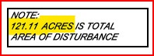

**Engineer’s Data: Sheet X Erosion Control Plan**

For full size, see Section 8 Appendix 4.

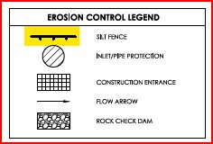

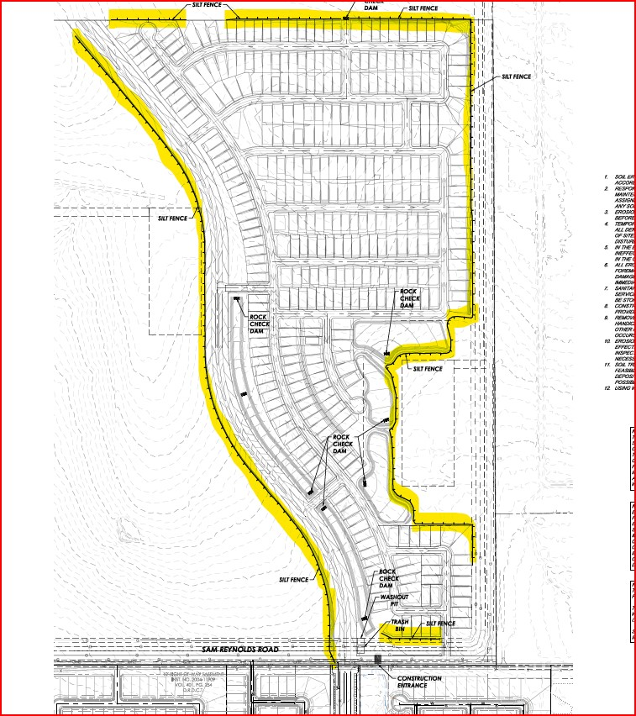

**Drainage:**

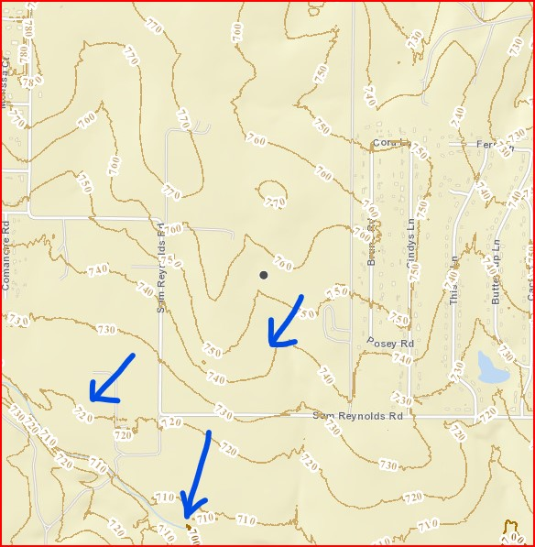

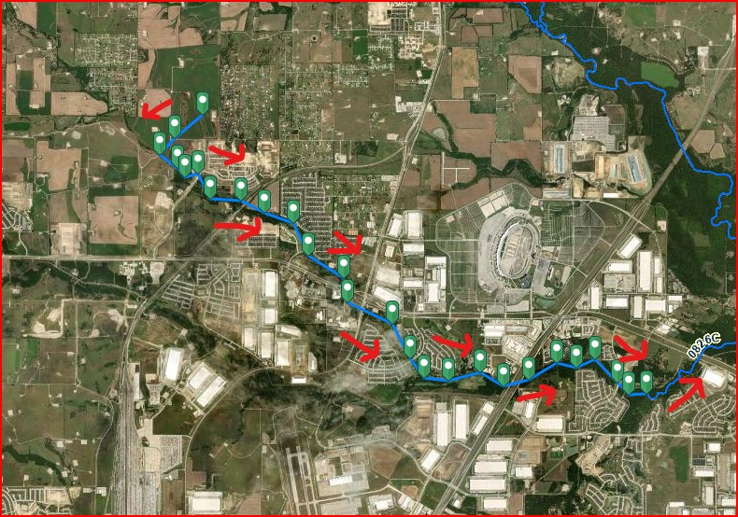

**Receiving Water Segment: Henrietta Creek – 0826C (Not listed as Impaired)**

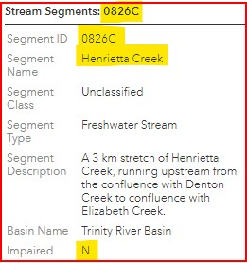

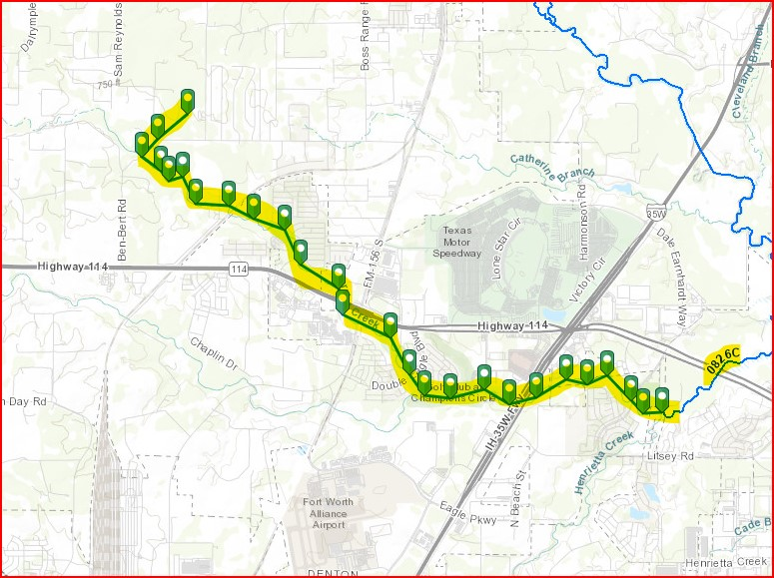

|  |  |  |
| --- | --- | --- |
| 1 | Project Name | **Wildflower Northeast Phase** |
| 2 | Site Location | NW of Sam Reynolds Rd. & Cindy’s Ln. Fort Worth, TX 76247 |
| 3 | Latitude/Longitude | Lat 33.0583 Long -97.338848 |
| 4 | Nature of construction activity | Site development to support construction of a Single-family Home Lot Sub-Division with phasing to include excavation, utilities, paving, and landscaping.  **SIC Code :**  6552 Land sub-dividers and developers |
| 5 | TCEQ Documents Required: CSN; NOI | CSN & NOI for Large Construction Activity |
| 6 | Define offsite support activities within 1 mile | --none identified at this time--- |
| 7 | Define offsite support activities over 1 mile. | --none identified at this time--- |
| 8 | Onsite- concrete batch plant operations | No |
| 9 | Onsite- concrete wash-out operations | yes |
| 10 | Site soil description | Mingo clay loam, Ponder loam, Sanger clay, Slidell clay, Somervell gravelly loam |
| 11 | Define site pre-construction topography | 1-5% slope |
| 12 | Define site pre-construction ground cover | Onsite: existing grass & trees |
| 13 | Define site pre-construction outfall location | Sheet flow drainage to the Southwest into Harriet Creek. Outfall Southeast into Elizabeth Creek with eventual confluence with Henrietta Creek. (water segment #0826C) |
| 14 | Define site pre-construction runoff coefficient | 0.30 |
| 15 | Define site post-construction outfall location | Lot and Pavement Sheet flow drainage into the purposed storm drainage system with discharge to the South into Harriet Creek. Outfall Southeast into Elizabeth Creek with eventual confluence with Henrietta Creek.  (water segment #0826C) |
| 16 | Define site post-construction runoff coefficient | 0.55 |
| 17 | Total disturbed acreage (including offsite) | 121.11 ac |
| 18 | General area map | ---see Section 4--- |
| 19 | SWP3 site map | ---see Section 7--- |
| 20 | Name of receiving waters | Harriet Creek |
| 21 | Name of MS4 receiving storm water runoff | City of Fort Worth, Texas |
| 22 | Segment Number of Classified Water Body | 0826C- Henrietta Creek |
| 23 | Texas Water Quality Impaired Waters 303(d) | Not listed as impaired |
| 24 | Copy of 3/5/18 TPDES TXR150000 regulations | ---see Section 5 |
| 25 | List of allowable non-storm water discharges | ---see Section 2.B |
| 26 | List of potential pollutants and pollutant sources | ---see Section 2.C |
| 27 | Construction Phases&Sequence of BMP Controls | ---see Section 3.A |
| 28 | Temporary & Permanent Stabilization Practices | ---see Section 3.B |
| 29 | Onsite wetlands or adjacent wetlands | Adjacent Tributary |

1. **List of Allowable Non-Storm Water Discharges**

The following non-storm water discharges are also eligible for authorization under this general permit:

**SWP3 Designee to check which items apply to this site:**

|  |  |  |
| --- | --- | --- |
| 1 | Discharges from fire fighting activities (not to include washing of trucks, run-off water from training activities, test water from fire suppression systems, and similar activities) |  |
| 2 | Uncontaminated fire hydrant flushings (excluding discharges of hyper-chlorinated water, unless the water is first de-chlorinated and discharges are not expected to adversely affect aquatic life), which include flushings from systems that utilize potable water, surface water, or groundwater that does not contain additional pollutants (uncontaminated fire hydrant flushings do not include systems utilizing reclaimed wastewater as a source water) |  |
| 3 | Water from the routine external washing of vehicles, the external portion of buildings or structures, and pavement, where detergents and soaps are not used and where spills or leaks of toxic or hazardous materials have not occurred (unless spilled materials have been removed; and if local state, or federal regulations are applicable, the materials are removed according to those regulations), and where the purpose is to remove mud, dirt, or dust |  |
| 4 | Uncontaminated water used to control dust |  |
| 5 | Potable water sources including waterline flushings (excluding discharges of hyper-chlorinated water, unless the water is first de-chlorinated and discharges are not expected to adversely affect aquatic life) |  |
| 6 | Uncontaminated air conditioning condensate |  |
| 7 | Uncontaminated ground water or spring water, including foundation or footing drains where flows are not contaminated with industrial materials such as solvents |  |
| 8 | Lawn watering and similar irrigation drainage, provided discharges comply with the permit |  |

**C. List of Potential Pollutants and Pollutant Sources**

**List of Potential Pollutants**

|  |  |
| --- | --- |
|  | Could include, but not be limited to: |
| 1 | Silt |
| 2 | Fuel |
| 3 | Floatable and bio-degradable trash, garbage and debris |
| 4 | Toilet liquids (human waste0 |
| 5 | Equipment/vehicle oil and grease and fuel |
| 6 | Chemical and hazardous materials stored on-site |
| 7 | Air born pollutants (eg. dust, asbestos) |
| 8 | Construction materials (eg. wrapping/packaging materials; cardboard, paper, plastic,wood) |
| 9 | Curing compounds, paints, solvents, stains |
| 10 | Concrete, cement, mortar |
| 11 | Line flushing chemicals; ie. Chlorine from line flushing |
| 12 | Unfiltered concrete washout |
| 13 | Leached metals |

**List of Potential Pollutant Sources**

|  |  |
| --- | --- |
|  | Could include, but not be limited to: |
| 1 | Disturbed ground |
| 2 | Fuel tanks |
| 3 | Toilets |
| 4 | Staging Areas: equipment staging, materials staging, dirt stockpile areas, borrow areas |
| 5 | Trash containers |
| 6 | Worker food wrappings |
| 7 | Equipment/vehicle leaks |
| 8 | Maintenance activities |
| 9 | Refueling activities |
| 10 | Storage Areas: chemical and hazardous materials |
| 11 | Line flushing |
| 12 | Concrete trucks |
| 13 | Concrete and asphalt batch plants |
| 14 | Concrete and mortar washout activities |
| 15 | Illegal on-site waste dumping |
| 16 | Waste waters. |
| 17 | Uncovered trash containers |
| 18 | Uncovered chemical and hazardous material containers |
| 19 | Metal product leaching |

**Note:** A description of controls and measures that will be implemented to minimize pollutant discharges from these sources is included in this SWP3 Section 4.

**SWP3 Site Maps**

**Location Maps**



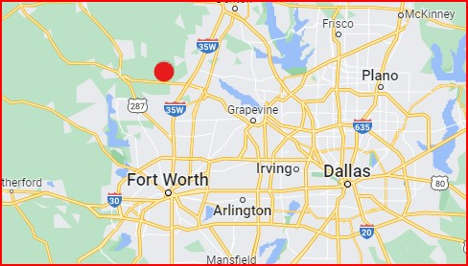

**Soil Map**

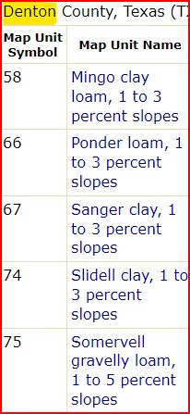

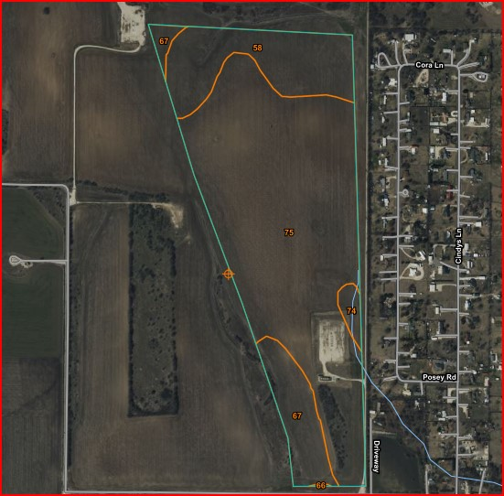

**Section 3: Construction Phases and BMP Sequence & Controls**

A. Construction Phases and Sequence of BMP Controls

B. Temporary and Permanent Stabilization Practices

**A. Construction Phases and Sequence of BMP Controls**

This section describes the ‘Construction Phases’ that will create major earth disturbing activities and the general timing or sequence for implementation of BMPs.

**Defining Construction Phases and Sequence of Major Earth Disturbing Activities**

The anticipated sequence of construction activities that involves earth disturbing activities and their associated BMPs are provided below.

|  |
| --- |
| **Project Description: Wildflower Northeast Phase**  Site development to support construction of a Single-family Home Lot Sub-Division with phasing to include excavation, utilities, paving, and landscaping.  **SIC Code:**  6552 Land sub-dividers and developers; 1611- Paving |
| **Pre-Construction Ground Conditions**  Existing Grass |
| **Sequence of Major Earth Disturbing Construction Activity**  Major Earth Disturbing Construction Activity will consist of:  **Earth Disturbing Activities:**   * Grading * Utility trenching * Firelane and parking lot sub-base * Building construction * Final stabilization |

**Living Document**

|  |
| --- |
| This SWPPP is considered a living document which can be changed by the authorized Operator in response to site conditions that may dictate the need for modifications to existing controls or the need for additional controls. |

**Note: Record Keeping Requirement**

|  |
| --- |
| Operator’s site supervisor will maintain the following records in the SWP3 and make readily available upon request to the parties listed in Part III.D.1 of the TXR150000 permit:  Record in the **SWP3 Record Logs Section 7:**   * **T**he start/stop dates for each phase of construction activity. * **I**nstallation and removal dates of each BMP control device. * **D**ates when construction temporarily or permanently cease on a portion of the site. * **D**ates when stabilization measures are initiated. |

**Procedural Requirements**

|  |
| --- |
| Prior to earth disturbing activities by the Operator:   * At least seven (7) days prior to initial earth disturbance, obtain TCEQ permit coverage for Large Construction Activities over 5 acres. (Exception: Immediate provisional permit authorization is granted for Small Construction Activities (less than 5 acres) and for Large Construction Activities submitting NOI application via the TCEQ website. * Submit copies of the NOI application and Construction Site Notices (CSN) to the local MS4(s) and to all other Secondary and Primary Operators. * Post a copy of all Operator CSNs on a sign at the jobsite for public viewing. |

**EROSION CONTROL GENERAL NOTES**

|  |  |
| --- | --- |
| **1** | Do not begin earth disturbing activities until provisional authorization has been obtained from TCEQ and local authorities. Provisional authority is immediately after the posting of the CSN Permit Form for Small Sites (less than 5 acres) and for Large sites (greater than 5 acres) if the NOI Application has been file with the TCEQ online STEERS system. Large sites (greater than 5 acres) that submit the NOI Application by US mail are not authorized until 7 days after postdate submittal. |
| **2** | Comply with all state and local erosion control ordinances. |
| **3** | Revisions should be made to the SWP3 as needed to accommodate changes to BMPs and BMP schedules. All revisions should be documented to the SWP3 Record. |
| **4** | Wash water pollutants shall not come into contact with storm water discharges from this site. |
| **5** | Oil and grease absorbing materials shall be readily available on-site and shall be promptly used to contain and/or clan up all fuel or chemical spills or leaks. |
| **6** | Dust control shall be accomplished by watering dry, exposed areas on a regular basis in accordance w/ local drought water restrictions. Spraying petroleum based or toxic liquids for this purpose is strictly prohibited. |
| **7** | Disturbed area of the site where construction activity will cease for more than 14 days must be seeded and watered with temporary vegetation. Areas where construction activity has permanently ceased shall be seeded/watered with permanent vegetation within 14 days of ceased activities. |
| **8** | All materials spilled, dropped, washed or tracked onto adjacent roadways by any vehicles exiting the site shall be cleaned or removed as soon a possible but no later than the end of the work day. |
| **9** | Accumulated silt deposits in sediment basin, detention pond, storm sewer inlets and pipes, rock check dams, and along silt fences shall be cleaned before the next rain event but no later than 7 days from inspection observation. Silt deposits shall not exceed over 50% of the height of the device. |
| **10** | Silt fence or straw-filled sediment logs shall be placed on the downstream side of all dirt stockpiles. |
| **11** | The TCEQ Permit cannot be terminated until all disturbed areas have been stabilized and all temporary structural controls such as silt fence have been removed. |
| **12** | The SWP3 designee shall update the SWP3 Site Map to reflect accurate locations of all structural controls and all areas for wash down, materials and equipment staging, location of hazardous materials, parking, portable toilets, concrete washout, maintenance, fuel storage and stockpiles. |
| **13** | SWP3 Inspection Reports shall be performed in strict accordance with the chosen schedule as allowed by the TCEQ regulations. |
| **14** |  |

|  |  |
| --- | --- |
| **Construction**  **Phase** | **BMP/Structural Controls Implementation Schedule** |
| **PreConstruction** | **Prior to initial construction and earth disturbing activities provide the following.** |
|  | * **Impact on Endangered Species:**  Protect endangered or threatened   species of animals, fish or plants and their habitat in or near the  construction activity area. The Operator(s) will review the list of Federal  and State endangered or threatened species located in the SWP3 Manual  and assure by means of pre-construction and on-going site  inspection that construction activities do not result in jeopardy to any of  the listed species in or near the construction activity area. Site personnel  should report to their management immediately any signs of  endangered or threatened species or habitat and contact the following  agencies to determine appropriate action:   1. U.S. Fish & Wildlife (817-277-1100) 2. TexasParks&Wildlife(512-389-8111) or 3. (<http://www.tpwd.state.tx.us/huntwild/wild/species/endang/index.phtml>)  * **Impact on Historical Places**: Assure construction activities and the discharge storm water from this site will not adversely affect registered Historic Places. Review the list located in the SWP3 Manual. Pre-construction site inspections should be conducted and personnel should report immediately any historic places found and contact the preservation agencies to determine appropriate action. Operator must comply with the National Historic Preservation Act and a) assure storm water discharge does not adversely affect a listed property or a property eligible for listing with the National Historic Register or b) obtain and comply with a written agreement between the Operator and the State Historic Preservation Officer (512-463-6100) (loaks@thc.state.tx.us) that outlines all measures to be undertaken by the applicant to mitigate or prevent adverse affects to the historic property. * **Impaired** **Body of Water:** Review **TXR150000 Storm Water Regulations Part II Section C.4.** Any discharge to impaired waters from this site that contain pollutants of concern detailed in any existing TMDL Plan must be consistent with the TMDL. Operator(s) must apply BMPs to comply with the conditions and requirements of the TMDL or TMDL Implementation Plan. Levels of discharge of pollutants of concern that are inconsistent with the TMDL or TMDL Implementation Plan are not allowed under the TXR150000 permit. If Operators for this site suspect or are aware of the existence of pollutants of concern for this impaired water body, the following is recommended: 1) Review the TMDL for pollutants of concern. 2) Analyze soil and storm water runoff samples to determine if pollutants of concern exist and the quantitative levels. 3) Determine if additional BMP and BPT are required for this site. BMP and BPT might include containment of storm water runoff, additional filtration and/or treatment of controlled release. |
|  | * **Pre-construction conditions:**  1. Record and document pre-construction conditions of site regarding paths of storm water flow and existing erosion and sediment loss patterns. This should include photographs of site conditions and paths of off-site storm water flow. (ie. sediment deposits & trash in offsite creeks, ponds, lakes. 2. It is recommended that an existing ‘soil analysis’ be performed to determine pre-construction soil conditions and possible soil contaminants. 3. It is recommended that a ‘water sample analysis’ be performed of existing pre-construction storm water runoff to define pre-construction levels of turbidity, sediment load and pollutants. It is also recommended that a continual program of ‘water sample analysis be maintained throughout the life of the project activity to establish baseline data for impact to offsite water ways. 4. Storm-water runoff should be treated by means of detention, sediment settlement, chemical treatment, filtering, etc. to assure non-polluted storm water exits the site into US water ways. 5. Sites that are adjacent to ‘wetlands’ or that discharge into ‘listed impaired waters’ in the State of Texas may need special permit from the Army Corp of Engineers or TCEQ to co-ordinate low impact or mitigation plans. |

|  |  |
| --- | --- |
|  | **BMP/Pollution Control Schedule** |
|  | 1. Review the list of BMP recommendation in this SWP3 and implement those that apply to this construction activity. Phase in additional controls as needed. 2. Apply the chosen BMPs and structural controls for all work areas including all offsite support areas (ie. stockpiling, borrow, equipment staging). 3. Note: Offsite support areas more than 1 mile away may require a separate authorization under the general permit according to disturbed area size. 4. Review and follow the requirements of the project’s civil drawing titled:   **Engineer’s Civil Sheet X Erosion Control Plan** |
|  | **Review SWP3 Site Map: Engineer’s Civil Sheet X Erosion Control Plan** |

|  |  |
| --- | --- |
| **Phase A** | **Grading** |
| note | Site superintendent and demolition contractors shall review the following list of BMP’s to be utilized during the ‘demolition’ activities:   1. On-site roll off trash container and haul trucks to transport site debris and trash to lawful landfill or recycled. 2. All floatable materials removed or placed in closed containers. 3. Silt fence, sediment logs or triangular filter dikes shall be installed in areas to prevent soil transportation onto paved areas to minimize runoff into streets. 4. All storm drains receiving storm water runoff to be protected with inlet filtration. 5. Removal of hazardous materials including asbestos by certified license contractor. 6. All on-site sources of contaminated water, sludge water, water standing in pits and containment areas to be properly disposed of. Do not allow this water to enter storm water drainage system. 7. Perform repairs and cleanup maintenance for controls such as silt fence, inlet protection and street tracking. 8. All on-site fuel storage to be contained from spills with secondary containment such as berm with liner or spill tank. 9. All leaks form fuel tanks, vehicles or construction equipment to be contained and properly removed as soon as discovered. 10. Dust control shall be provided as needed. 11. The contractor is respoinsible for dust or dirt in the air from construction activity. 12. All trash and material debris removed to lawful landfill or recycled. 13. All floatable materials removed or placed in closed containers. 14. Hazardous materials and liquids properly disposed of and removed from the site. 15. All ground oil, grease, chemical spills removed and properly disposed of. 16. All contaminated water removed and properly disposed of. 17. All metal stockpiles subject to rusting removed and properly disposed of. 18. All street and paved areas to be swept clean.   **Schedule:** Prior to demolition activities. |

|  |  |
| --- | --- |
| 1 | **Erosion & Sediment Control BMPs**: |
| 2 | **Preserve Vegetation and Perimeter Grass Buffer Strips**  Utilized existing vegetation and perimeter grass buffer when feasible  Stage construction site when feasible to preserve vegetation  *Vegetation is more effective and easier to maintain than temporary sediment controls  **Not appropriate for concentrated high velocity flow areas |
| 2 | **Install Silt Fence**  Install perimeter silt-fence where storm-water exits the project limits.  Include offsite areas used for stockpiling or equipment/vehicle/material staging.  **Schedule:** Prior to initial earth disturbance |
| 4 | **Install rock entry pad or utilize existing concrete entries.**  Clean street daily from debris by existing vehicles.  Provide construction entrance with anti-tracking capabilities. (ie. existing paving, gravel entrance or rock entrance with liner).  **Schedule:** Prior to initial earth disturbance |
| 5 | **Provide filtration protection for existing storm drain inlet throats.**  **Schedule:** Prior to initial earth disturbance. |
| 6 | Provide filtration protection for drainage plumes at offsite exit location (ie. straw-filled sediment logs, hay bale, rock sock).  **Schedule:** Prior to initial earth disturbance. |
| 7 | BMP-Utilize diversion dikes to direct water flow where practical.  **Schedule:** Prior to initial earth disturbance. |
| 8 | Provide adequate trash containers and disposal service. Haul away trucks should be properly tarped prior to departing site.    **Schedule:** As soon as needed. |
| 9 | Provide scheduled service for on-site toilets.  **Schedule:** As soon as needed. |
| 10 | Provide 2nd containment for on-site fuel storage  **Schedule:** As soon as needed. |
| 11 | Protect downstream side of dirt stockpiles.  **Schedule:** As soon as needed. |
| 12 | Clean streets and storm inlets if offsite tracking occurs.  **Schedule:** As soon as needed. |
| 13 | Protect drainage pipe inlets/outfalls & open drainage to offsite water routes (swales, creeks, rivers, ponds, lakes) w/ rock filter devices, hay-bales or silt-fence where needed.  **Schedule:** As soon as needed. |
| 14 | Protect drainage over paved areas with hay-bales, sediment logs, rock filter devices, etc where needed.  **Schedule:** As soon as needed. |
| 15 | Utilize sedimentation traps/basins/ponds where feasible to control off-site silt flow.  **Schedule:** During initial grading activity. |
| 16 | Protect all offsite drainage routes w/ silt filtering devices such as:   * Existing storm sewer inlets. * MS4 bar ditches. * Street culvert pipe. * Outfalls with open discharge to fields, ditches, streams, creeks, ponds, etc. * Utilize structural controls such as: Silt fence, rock filter devices, hay-bales, sediment traps or basins or ponds.   Install rock check dams where drainage exists site.  **Schedule:** As soon as drainage channel grading is complete. |
| 17 | Provide repairs and maintenance for all control devices as needed.   * Include removal of silt build-up when the device has become ineffective (eg. only half height or less remains on silt-fence or rock filer dams). * Include re-dress of rock construction entrances/exits when excessive dirt build-up renders anti-tracking ineffective. |
| 18 | **Provide watering to minimize dusting** during demolition activities.  See Note 22 of Civil Sheet C-01 General Notes/Grading.  **Schedule:** As soon as demolition activities have begun. |
| 19 | Filter water runoff from demolition areas to control offsite transportation of pollution materials. ( ie. gravel, rock filter, straw logs, silt fence, sediment trap/basin, grass areas)  **Schedule:** As soon as needed |
| 10 | Assure in accordance with Federal, State and local regulations that all utility lines above and below ground are properly terminated and sealed. Same applies to underground storage tanks (ie. fuel).  **Schedule:** As soon as needed |
| 21 | At the end of each day’s activities, pickup all floatable trash/debris & dispose to bins. |
| 22 | Provide proper storage/disposal of chemical and hazardous materials. Report significant spills to proper authorities.  **Schedule:** As soon as needed. |
| 23 | Clean offsite discharges of silt or pollution materials.  **Schedule:** As soon as needed. |

|  |  |
| --- | --- |
| 24 | **General House Keeping:**   * Clean streets and storm inlets when offsite tracking occurs. * Pickup daily trash/floatable debris from all work areas and offsite areas. * Redress construction exits with clean rock when needed.   **Schedule:** Review daily. |
| 25 | Provide dust control as needed: watering, ground stabilization, control vehicle traffic, etc. See Section 4.9 of this SWP3 Manual.  **Schedule:** During initial demolition and during grading activity. |
| 26 | Initiate stabilization measures (grass, erosion mat, rock) in disturbed areas where construction activity will cease for more than 14 days (ie. final graded areas).  **Note:** Exceptions are defined in **TXR150000 Part 3 Section F.2.b.iii (page 30).**  Be aware of the following requirements:   * In areas where temporary stabilization measures are infeasible, the operator may alternatively utilize temporary perimeter controls. * The operator must document in the SWP3 the reason why stabilization measures are not feasible, and must demonstrate that the perimeter controls will retain sediment on site to the extent practicable. * The operator must continue to inspect the BMPs at the frequency established in Section III.F.7.(a) of the permit for un-stabilized sites. |
| 27 | **SWP3 Site Inspections**  Provide site inspections as defined in Section 6 of this SWP3 Manual. |
| 28 | **Maintenance and Repairs**   * Repair and maintain all control devices as needed to assure they can operate effectively prior to the next rain event if feasible. * If maintenance is not practical prior to the next anticipated rain event, the reason shall be documented in the SWP3 and maintenance shall be completed as soon as practical. * **Important Note**: Erosion and sediment controls that have been intentionally disabled, run-over, removed or otherwise rendered ineffective must be replaced or corrected immediately upon discovery. * If periodic inspections indicate a control has been used incorrectly, is performing inadequately, or is damaged, then the operator must replace or modify the control as soon as practicable after making the discovery. * Sediment must be removed from sediment traps and sedimentation ponds no later than the time that design capacity has been reduced by 50%. For perimeter controls such as silt fences, berms, etc., the trapped sediment must be removed before it reaches 50% of the above-ground height. Include re-dress of rock construction entrances/exits when excessive dirt build-up renders anti-tracking ineffective * Operator shall remove fugitive silt and debris deposits discovered past the project limits. If sediment escapes the site, accumulations must be removed at a frequency that minimizes off-site impacts, and prior to the next rain event, if feasible. Operator must work with the owner or operator of adjacent offsite property to remove the sediment. |

|  |  |
| --- | --- |
| **Phase B** | **Install Underground Utilities.** |
| 1 | Review and maintain previous Phase BMPs and Controls |
| 2 | Install controls necessary in disturbed areas to prevent offsite silt flow past project limits (ie. silt fence, rock filters, slow-down checks across bar ditch drainage areas).  **Schedule:** As soon as project limits are at risk of offsite silt flow. |
| 3 | Install inlet protection for all newly installed storm drains and for all newly constructed drainage inlet bottoms and at the end of exposed storm sewer pipes.  **Schedule:** As soon as they are at risk of silt flowing into inlet. |
| 4 | Waterline flushing should include control of pollutants in the discharge (ie. discharge filtering, chlorine dissipation prior to entering storm drain system, containment/filtering). Utilize diffuser or aerial discharge to expose chlorine to air and sunlight.  **Schedule:** As soon as water line flushing begins. |
| 5 | Proper storage/disposal of chemical and hazardous materials. Report significant spills. Complete Table 7 of SWP3 Manual Section 7.  **Schedule:** As materials are stored on-site. |
| 6 | Install a designated concrete-washout area with runoff protection.   1. Concrete truck washout is allowed under this permit provided the requirements are met as defined in TPDES TXR150000 General Permit Part V. 2. Discharges of storm water from on-site batch plants for concrete or asphalt are allowed under this permit provided the requirements are strictly met as defined in TPDES TXR150000 General Permit Part IV. This does not include any waste-water from batch plant activities.    * If the Operator (s) defined in this SWP3 do not want to authorize batch plant activity under their permit then the batch plant operators should be advised to obtain authorization under an alternate permit and SWP3.   **Schedule:** As soon as wet concrete is available on-site. |
| 7 | Energy dissipation device (rock rip-rap, etc.) at outfalls  **Schedule:** As soon as outfalls are completed. |
| 8 | Inlet protection for all phases of construction of new storm drains& pipe conveyance systems.  **Schedule:** As soon as inlet boxes are set in ground or open ended pipe exist. |
| 9 | Temporary sediment basin(s) may be removed after all storm sewer systems are functional and inlet protection is in place. |
| **Phase C** | **Paving: Finalize pavement sub-grade preparation and install pavement.** |
| Note | **On Site Concrete Batch Plant Operations---EXCLUSION**    **Note:** The SWPPP Narrative and TCEQ Stormwater Discharge Permit for this project **does not** cover the TXR150000 compliance requirements for any planned on-site Concrete Batch Plant Operation. On-site Concrete Batch Plants should be separately permitted by the batch plant operator.    **Important:** The permitted Operator for this project construction activity should communicate to any operator of 'concrete batch manufacturing' that they be responsible for compliance to the TXR150000 Part IV  requirements under their own separate TCEQ Storm Water Discharge permit. The location of any batch plant operation will be noted on this Swppp's site map but compliance to all details defined in the TXR150000 Regulations Storm Water Discharge Regulations for General Construction Activity Part IV for Stormwater Runoff from Concrete Batch Plants, starting at page 42 thru page 46, will be the sole responsibility of the batch plant operator. A copy of the current TXR150000 Storm Water Discharge Regulations for General Construction Activity is located in this SWPPP Narrative.    Operators of 'onsite Concrete Batch Plants' should obtain a separate permit for storm water discharge due to the more extensive requirements for compliance and so not to put the risk of illicit discharges on the 'site development' operator but rather on the operator of the 'batch plant' itself.    Special requirements apply concerning benchmark water sample analysis and ongoing water sampling from storm water events. Stringent documentation to the SWPPP is required for outfall discharges that exceed benchmark pollutant levels. Stringent inspection requirements are required. Ongoing staff training is required prior to and during plant operations. Absolutely no wastewater discharges are allowed. |
| 1 | Maintain Previous Phase BMP’s and Controls |
| 2 | Install a designated concrete-washout area with runoff protection. See Phase C Item 6 above.  Note: On-site batch plants (concrete/asphalt) must comply w/ strict requirements of the TXR General Permit.  **Schedule:** As soon as wet concrete is available on-site. |
| 3 | Proper storage/disposal of chemical and hazardous materials.  Note: Report significant spills.  **Schedule:** As soon as materials stored on-site. |
| 4 | Inlet protection for all storm drains.  **Schedule:** As soon as exposed inlets exist. |
| 5 | Erosion mat and/or silt fence in areas needing protection such as behind curb, wheelchair ramps and corners of new poured approaches.  **Schedule:** As soon as final grade achieved behind curb or ramp areas. |
| 6 | Clean streets and inlet-protectors.  **Schedule:** As soon as needed. |
| 7 | Remove temporary entrance/exits only just prior to pavement construction in these areas. |

|  |  |  |
| --- | --- | --- |
| **Phase D** | **Building Structure** | |
| 1 | Maintain Previous Phase BMP’s and Controls | |
| 2 | Install a designated concrete-washout area with runoff protection. See Phase C Item 6 above.  Note: On-site batch plants (concrete/asphalt) need to comply with strict requirements of the TXR150000 General Permit.  **Schedule:** As soon as wet concrete is available on-site. | |
| 3 | Proper storage/disposal of chemical and hazardous materials.  Note: Report significant spills.  **Schedule:** As soon as materials stored on-site. | |
| 4 | Inlet protection for all storm drains.  **Schedule:** As soon as exposed inlets exist. | |
| 5 | Erosion mat and/or silt fence in areas needing protection such as behind curb, wheelchair ramps and corners of new poured approaches.  **Schedule:** As soon as final grade achieved behind curb or ramp areas. | |
| 6 | Clean streets and inlet-protectors.  **Schedule:** As soon as needed. | |
| **Phase E** | **Final Site Stabilization & Landscaping** | |
| 1 | Review details of Civil Sheet Landscaping Plan if available.  Complete seeding/planting of vegetated areas in accordance with the landscaping plans to establish final stabilization. | |
| 1A | Protect all open disturbed areas where construction activity is completed with vegetation, erosion mat, sod, shrub beds, rock, landscaping, etc. Slope areas should be properly protected and stabilized with seeding and erosion mat. Provide erosion mat and/or silt fence in areas needing protection such as areas sloping into drainage channels, behind street curb, behind wheelchair ramps and corners of new poured street approaches.  **Schedule:** As soon as final grade achieved in these areas. | |
| 2 | Initiate re-vegetation in disturbed areas within 1 day where construction activity is expected to cease for more than 14 days (ie. all areas that are final graded). | |
| 3 | Remove temporary erosion control devices (eg. silt-fence, inlet-protection, rock entrances, rock dams) after final stabilization has been achieved (minimal 70% grass perennial coverage).  **Schedule:** As soon as area is final stabilized with 70% grass coverage or protected with erosion mat, sod, mulch, rock, pavement, etc. | |
|  | **Record Keeping Requirements** | |
| 1 | Record on SWP3 Site Map & Section 7 SWPPP Logs areas that have been permanently stabilized and how (eg. Pavement, sidewalks, landscaping, sod, mulch, rock, rip-rap, erosion mat). Refer to landscape drawing in civil drawing for this site if available. | |
|  | | **Additional Controls: Applies to all phases of construction** | |
| 1 | | De-Watering Activities:   * Design and utilize appropriate controls to minimize the offsite transport of suspended sediments and other pollutants if it is necessary to pump or channel standing water from the site. * De-watering activities should be treated. * Utilize discharge filtering. * Discharge to grassy areas/swales, sediment basins/ponds, rock lined areas, etc. * Some disposals may require transport offsite by truck to prevent polluting water resources. * Do not discharge directly into storm drains. * Do not discharge polluted or contaminated water. | |
| 2 | | Material Stored on-site:   * Review Section 3.C for description of on-site stored materials. * Description of controls to minimize pollutants from these materials is included in this SWP3. * Operator will complete the SWP3 Log: Table 4 for a description of hazardous construction materials expected to be stored on-site * All chemical, liquid product, petroleum products and non-inert wastes should be properly stored in designated areas protected from vandalism, contained with lids and contents labeled. * Clean up material should be made available on-site in storage area. * Trash containers shall be emptied when full and contents disposed of in accordance with local laws and permits. * Refer to SWP3 Manual Section 4.22 for spill response guide. * Refer to SWP3 Manual Section 3.C for a list of pollutant sources. | |
| *3* | | Offsite Tracking and Generation of Dust:   * Minimize, to the extent practicable, the off-site vehicle tracking of sediments and the generation of dust. * A description of controls is included in this SWP3 Section | |
| 4 | | Velocity Dissipation Devices:  Place velocity dissipation devices at discharge locations and along the length of any outfall channel (i.e., runoff conveyance) to provide a non-erosive flow velocity from the structure to a water course, so that the natural physical and biological characteristics and functions are maintained and protected. | |
| 5 | | Potential Pollutant Sources:  Refer to SWP3 Manual Section 3.C for a list of pollutant sources. | |
| 6 | | BMPs for eligible non-storm water components of the discharge:  Provide appropriate pollution prevention measures for all eligible non-storm water components of the discharge, as listed in TXR150000 Part II.A.3. of the permit. (ie. containment and filtering) | |
| 7 | |  | |
| 8 | |  | |
| 9 | |  | |
| 10 | |  | |
| **Ongoing** | | **Ongoing Operator Responsibilities** | |
| **Inspections**  **&**  **Maintenance** | | * Refer to Section 6 of this SWP3 Manual. * Provide scheduled inspection reports and file in SWPPP manual. * Inspection reports should identify all incidences of non-compliance. * Review Phase A.17 for rules for maintenance/repair schedule. * If 3rd party inspectors are used, be certain proper signature delegation has been recorded. See SWP3 Section 1 documents. * Operator site supervisor is responsible for SWP3 recordkeeping duties as defined in the Record Keeping requirement that follows | |
| **Record Keeping** | | 1.Operator site supervisor must maintain an accurate SWP3 Site Drawing indicating location of all a) erosion control devices b) concrete wash-out c) portable toilets d) fuel storage e) hazardous chemical storage f) trash containers g) grass buffers h) final stabilized areas i) storm water outfalls.  2. Operator site supervisor to record dates in the SWP3 Logs Section 7 for:   1. start/stop dates of each phase of construction. 2. installation dates of erosion control devices 3. dates of repair of erosion control devices 4. dates of removal of erosion control devices 5. list all chemical and hazardous materials to be stored on-site. 6. Record all changes and revisions to the SWP3 in Logs. | |
| **Training** | | Workers and sub-contractors should receive training for the following:   * Procedures for SWP3 Compliance * Procedures for spill response * Procedures for trash disposal. | |
| **Maintenance** | | Review above item Phase A.17 for rules for maintenance/repair schedule. | |
| **Final Site Stabilization** | | Upon final site stabilization, remove all temporary controls such as silt fence, sediment logs, rock berms and inlet protectors on storm drains. | |

|  |  |
| --- | --- |
|  | **Terminating the TCEQ Permit** |
|  | **Small Construction Sites:**   1. Remove the posted TCEQ CSN Form; sign termination date on bottom of the form. 2. Send copy to SWP3 Manual, all MS4’s receiving storm water discharge from this site & to other Operators, including new Operators taking over site responsibilities.   **Large Construction Sites:**   1. Remove the posted TCEQ CSN Form. 2. Submit a signed Notice of Termination (NOT) Form to TCEQ. 3. Send copy of the CSN & NOT to SWP3 Manual, all MS4’s receiving storm water discharge from this site & to all other Operators, including new Operators taking over site responsibilities. Permit ends at midnight on date of removal of CSN for Small Construction Sites and post mark date of NOT for Large Construction Sites. |
|  | **Retainage of Records**  Records must be retained for a minimum period of at least 3 years after one of the following is achieved:   1. Submittal of a Notice of Termination (NOT). 2. The date final stabilization has been achieved on all portions of the site that is the responsibility of the permittee. 3. Another permitted operator has assumed control according to overall areas of the site that have been finally stabilized. |

**B. Temporary and Permanent Stabilization Practices**

The following stabilization measures should be initiated as soon as practicable on portions of the site where construction activities have temporarily and/or permanently ceased.

**Description of Temporary Erosion& Sediment Control Practices**

|  |  |
| --- | --- |
| 1 | Silt fence to protect disturbed ground at project limits. |
| 2 | Rock entrance to provide anti-dirt tracking into streets. |
| 3 | Inlet protectors for existing storm drains. |
| 4 | Slow-down silt-fence cross-checks in drainage channels to minimize erosion effects. |
| 5 | Rock filter dams in drainage areas such as creek beds. |
| 6 | Designated areas for equipment, vehicle and materials storage. |
| 7 | Silt fence protection for on-site and offsite dirt stockpiling or offsite borrow areas. |
| 8 | Street sweeping and cleaning of storm drain inlet protectors |
| 9 | Daily pickup of floatable trash and debris. |

**Description of Temporary Stabilization Measures**

|  |  |
| --- | --- |
| 1 | Initiate stabilization measures (grass, erosion mat, rock) in disturbed areas within 1 day where construction activity will cease for more than 14 days (ie. final graded areas).  **Note:** Exceptions are defined in TXR150000  Be advised of the following requirements:   * In areas where temporary stabilization measures are infeasible, the operator may alternatively utilize temporary perimeter controls. * The operator must document in the SWP3 the reason why stabilization measures are not feasible, and demonstrate that the perimeter controls will retain sediment on site to the extent practicable. |
| 2 | The operator must continue to inspect all BMPs at the frequency established in the SWP3. |

**Description of Permanent Stabilization Measures**

|  |  |
| --- | --- |
| 1 | Disturbed areas will be covered with:   * Grass vegetation and landscape areas. * Rock at outfall drainage paths to provide energy dissipation and minimize erosion * Paved surfaces such as parking areas, firelanes, sidewalk areas and building pad. |
| 2 | Final stabilization must be achieved prior to termination of permit coverage by Owner Operator. |

**Description of Permanent Storm Water Conveyance**

The following controls are considered measures to be installed during construction that will provide permanent storm water conveyance after construction activity is completed:

|  |  |
| --- | --- |
| **Item** | **Description** |
| 1 | Lot and Pavement Sheet flow drainage into the purposed storm drainage system with discharge to the South into Harriet Creek. Outfall Southeast into Elizabeth Creek with eventual confluence with Henrietta Creek. (water segment #0826C) |